

Fantasy Barclays Premier League Weekly Starting Lineup Optimization

NagaShrikanth Ammanabrolu _________________________

Nikhil Soman _________________________

Adwait Deshpande _________________________

Vidit Brahmankar _________________________

Kislay Kumar Rai _________________________

December 02, 2015

**Introduction**



Fantasy Sports have risen in popularity over the recent years, since the Internet boom. Fantasy Sport is a virtual game environment where participants assemble their own virtual teams constituting real players of a professional sport. These teams compete based on the statistical performance of those players' players in actual games. The player performance is converted into points that are compiled and totaled according to a roster selected by each fantasy team's manager.

The Fantasy Sports Trade Association (FSTA) estimates 56.8 Million people over age 12 have played Fantasy Sport in the US & Canada in 2015.

Fantasy Barclays Premier League is the leading fantasy sports provider in the UK with 3 million users.

* Winning 1st Prize of the Fantasy league offers £25,000, and other monthly & quarterly prizes.
* A fantasy team is pitted against 3 Million other fantasy teams for the top spot, and individual leagues can also be created.

**Data Collection**

The official website of the Fantasy Barclays Premier League at fantasy.premierleague.com has been used to collect the data.

The data used for this project is for the initial 12 games played out of 38 in the current 2015-16 season.

**Objective Overview**

The primary objective of this project is to come up with a model formulation, allowing Fantasy Barclays Premier League users to choose the optimum mix of starting lineup players. Through the use of Excel Solver and Simplex Linear Programming, we are optimizing the drafting of players for maximizing the weekly total score of a team on the fantasy BPL.

**Problem Statement**

With over 700 players across 20 different Barclays Premier League teams, choosing the right mix of 15 players to give you the most points, while not stretching the budget constraints is a difficult task. Similar in its approach to different Fantasy leagues for NHL, NBA and MLB, Fantasy Barclays Premier League is one of the most popular Fantasy Soccer games online with 3 million registered users.

Choosing the perfect match of players for a fantasy team which would result in maximum weekly points, while adhering to the league rules is a stiff competition. Optimization techniques using Simplex Linear Programming would make it easier for users to optimize their best set of starting lineup players on the Fantasy league.

**Formulation Approach**

The process of optimization of Fantasy Barclays Premier League starting lineup begins with the understanding of the rules of the game. A Fantasy League game has certain sets of rules and conditions to which all of the users must abide to.

Given the total number of available fantasy league players at 700, the maximum budget of £100 Million and much more rules as such, formulating the problem at hand efficiently begins with a clear understanding of the constraints of such a Fantasy sport.

**Variables & Constraints:**

* Variables:
  + - 700 Fantasy players, across 20 different teams.
* Constraints (For Selected the Top 15 Players):
  + Total budget must not exceed £100 million.
  + There must be a total of 15 players.
    - There must be exactly 2 Goalkeepers
    - There must be exactly 5 Defenders
    - There must be exactly 5 Midfielders
    - There must be exactly 2 Strikers
  + Not more than 3 players must be selected from a single team.
* Constraints (For Selected the Starting 11 Players):
  + There must be a total of 11 players.
    - There must be exactly 1 Goalkeeper
    - There must be at least 3 Defenders
    - A maximum of 5 Midfielders can be chosen
    - There must be at least 1 Forward

**Project Workflow**

Using the official website of the Barclays Fantasy Premier League and the subsequent data for the 2015-16 season (12 out of 38 games played until now), data is extracted and organized to be easily read and analyzed using Excel Solver.

A major part of the problem lies in the number of constraints and variables which are approximated to be around 30+ and 700 respectively. Such analysis of large datasets is prohibited in Excel Solver, which limits the number of variables to 200 at any given time. This makes us to organize our data by the different player positions (Goalkeeper, Defender, Midfielder, and Striker) into different Excel spreadsheets.

The analysis of the different positions are done individually and the top players from each of these categories will be called upon into the final Excel spreadsheet for analysis. The player index rating would be used to calculate the efficiency of players, who would return the maximum points in any game week.

The player index we are using for analysis of player efficiency would be calculated by finding the cost per point, from the player’s accrued points until now and his cost in the market. The efficient set of players would be determined from their cost per point, with the player costing the least per point considered into the starting lineup. Below is a flow diagram of the process we’re implementing to obtain the optimized set of fantasy premier league starting lineup.

The entire set of data (700 Players, their accumulated points and Total cost in the market) is extracted from the official website.

Given the limitations of Solver, the most efficient players from each of the four player positions would be extracted into a single Excel spreadsheet of 200 players for the final analysis.

The constraints, variables and objective function are obtained from the official fantasy gameplay rules, which are listed below:

1. The total budget, which must not exceed £100 Million.
2. Squad Size: Total of 15 players (including substitutes)

* 2 Goalkeepers
* 5 Defenders
* 5 Midfielders
* 3 Strikers

1. Not more than 3 players to be selected from a single team.
2. From the total of 15 players, the starting lineup must contain exactly 1 Goalkeeper, at least 3 Defenders, and at least 1 forward at any given point of time.

Using these above constraints and the player index rating, the weekly optimal starting lineup of 11 players will be extracted.

**Methodology**

**Player Performance Index (PPI)**

The Player Performance Index is determined by calculating the cost per point, from the points accrued until now and the player’s cost in the market.

The player with the least cost per point are considered into the starting lineup.

**Goalkeepers**

10 Top Goalkeepers out of 61 total Goalkeepers have been selected. These players have been selected after ordering them according to their cost per point in the fantasy league. The top 10 Goalkeepers giving the most fantasy points at a minimum cost are considered for further analysis.

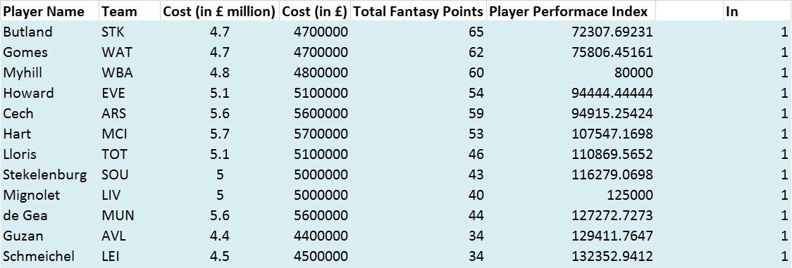

**Defenders**

90 Top Defenders out of 181 total Defenders have been selected. These players have been selected after ordering them according to their cost per point in the fantasy league. The top 90 Defenders giving the most fantasy points at a minimum cost are considered for further analysis.

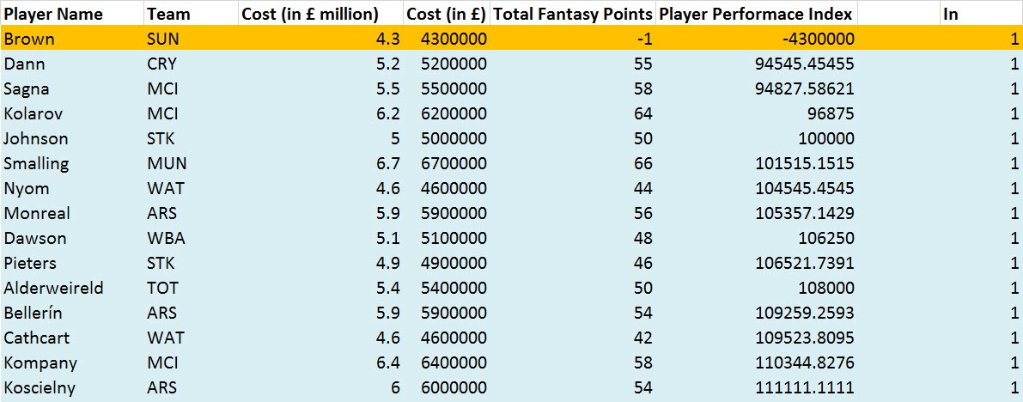

**Midfielders**

70 Top Defenders out of 181 total Defenders have been selected. These players have been selected after ordering them according to their cost per point in the fantasy league. The top 70 Defenders giving the most fantasy points at a minimum cost are considered for further analysis.



**Forwards**

30 Top Forwards out of 93 total Forwards have been selected. These players have been selected after ordering them according to their cost per point in the fantasy league. The top 30 Forwards giving the most fantasy points at a minimum cost are considered for further analysis.

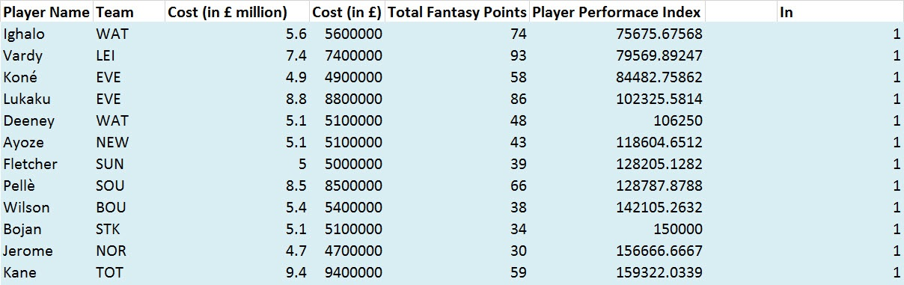

**Selecting the Top 15 Players**

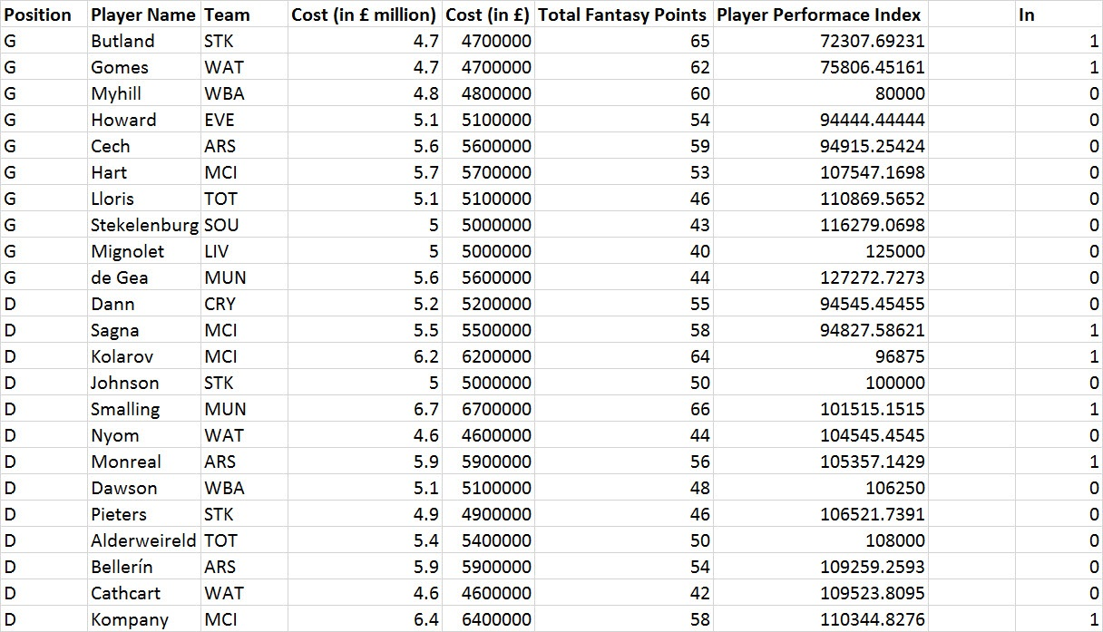

The selected Top 200 players out of the entire roster of 700 players are now tabulated in a single Excel spreadsheet as shown before. All of these players are initialized to 0, indicating that they are not selected into the final team. Using Excel’s built-in IF conditions, all of these players are initiated to ‘0’ or ‘Blank’ according to their positions as Goalkeeper, Defender, Midfielder or Forward.

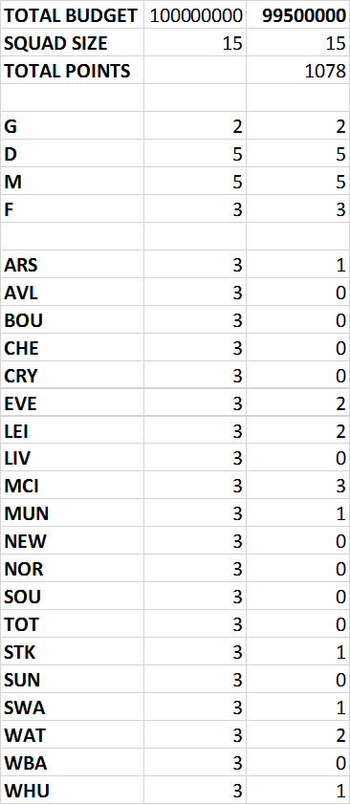

Using the aforementioned procedure, all of the fantasy team’s constraints are defined as shown above. Here, the maximum number of players from each team, the total budget, total number of players, and number of players for each position have been defined for further analysis using Excel Solver.

**Using Excel Solver**

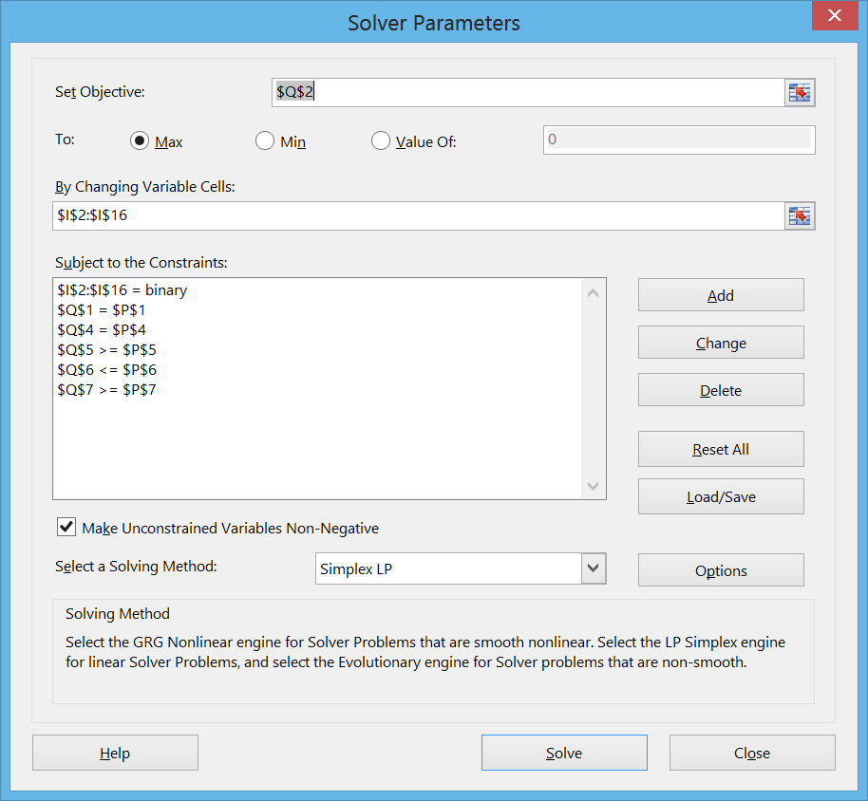

As seen from the above screenshot of the process using Excel Solver, the Objective function is set to the Total Points cell, which has to be maximized.

The changing variable cells are set as the Initialization column, whose values vary only between 0’s and 1’s as being set as ‘Binary’ while defining the constraints.

Other constraints included in Excel Solver are the constraints related to the number of players in each position and other constraints as described earlier.

**Results**

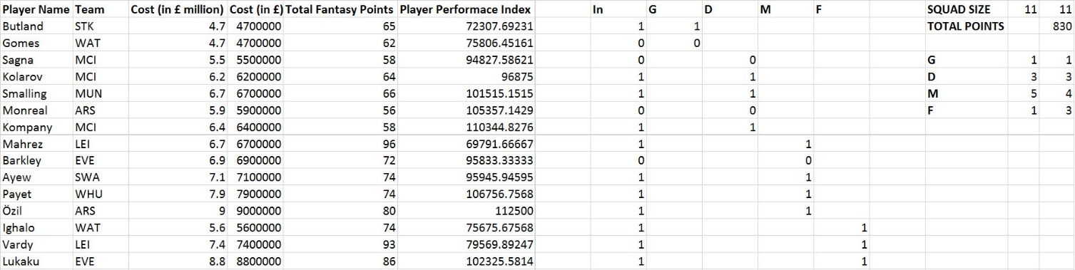

After the Top 15 players out of the 200 shortlisted players are selected, a starting team of 11 players has to be chosen as previously mentioned in the project workflow section. These 15 players are again initialized to 0’s and a final lineup of 11 players are selected, whose results are summarized above.

The final starting lineup is summarized below:

**Starting 11 Players:**

**Formation:**

* 1 Goalkeeper
* 3 Defenders
* 4 Midfielders
* 3 Forwards

Butland (G) Stoke City

Kolarov (D) Manchester City

Smalling (D) Manchester United

Kompany (D) Manchester City

Mahrez (M) Leicester City

Ayew (M) Swansea City

**Total Points Earned:**

* 830 Points

**Total Budget Used:**

* £99.5 Million

Payet (M) West Ham Utd

Özil (M) Arsenal FC

Ighalo (F) Watford FC

Vardy (F) Leicester City

Lukaku (F) Everton FC

**Conclusion**

The final optimized Starting 11 players of the Fantasy Barclays Premier league successfully met all of the league rules.

The fantasy starting lineup optimization has to be done on a weekly basis, eliminating any injured or suspended players.

**Team Members and Duties**

Kislay Kumar Rai – Data collection, extraction and preparation for analysis.

Adwait Deshpande – Formulation of problem constraints, variables and objectives.

Vidit Brahmankar – Formulation of problem constraints, variables and objectives.

Nikhil Soman – Final Data optimization using Excel Solver.